University of Central Punjab

**Faculty of Information Technology**

# Object Oriented Programming

|  |  |  |
| --- | --- | --- |
| **Lab 14** | |  |
| **Topic** | Aggregation and Multiple inheritance |
| **Objective** | The basic purpose of this lab is to implement the concept of multiple and multilevel inheritance |
|  | | |

**Instructions:**

* Indent your code.
* Comment your code.
* Use meaningful variable names.
* Plan your code carefully on a piece of paper before you implement it.
* Name of the program should be same as the task name. i.e. the first program should be Task_1.cpp

**Students are required to work in multiple files i.e .h and .cpp**

**Task1:**

A car has an engine, at most 2 AC’s, a handle to control the gears and a brake. If the car is manual, it has a clutch, otherwise it doesn’t. Make 3 constructors of each class, a default and 2 parameterized. Using constructor initializer lists, call the overloaded constructors of the composed and aggregated classes from the container class.

**Task 2:**

Provide the C++ implementation of the following.

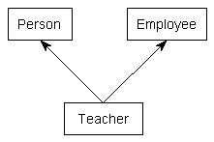

The Person class has name and age as its attributes. It has an overloaded constructor to initialize the values and appropriate accessor and mutator methods. The Employee class has name of the employer and wage as its attributes with an overloaded constructor and appropriate accessor and mutator methods.

**Task 3:**

A personal computer has a CPU, a motherboard, a RAM, a GPU, a HDD, a Display and a Sound, along with other additional components. Each of these components is an object in itself. Thus, a Personal computer is a complex object composed of several smaller level objects. Each of the smaller objects has its own attributes and functions. For example:

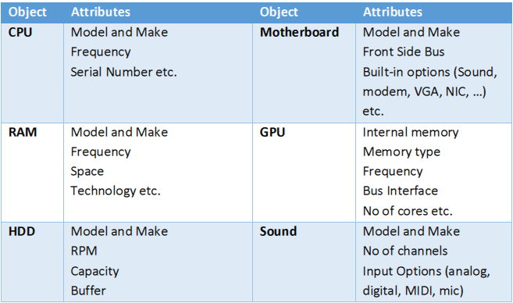

NOTE: Only Make UML Diagram.